Home : World : Palestinians say they'll go to UN for recognition
Palestinians say they'll go to UN for recognition
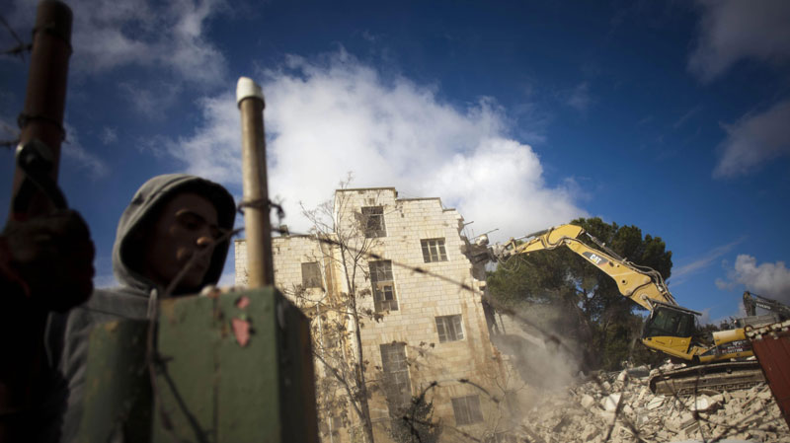
Israeli bulldozers demolish the Sheperd Hotel in the east Jerusalem neighborhood of Sheik Jarrah, Sunday, Jan. 9, 2011. (AP / Bernat Armangue)
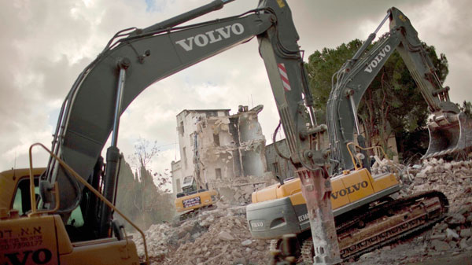

Israeli bulldozers demolish the Sheperd Hotel in the east Jerusalem neighborhood of Sheik Jarrah, Sunday, Jan. 9, 2011. (AP / Bernat Armangue)

